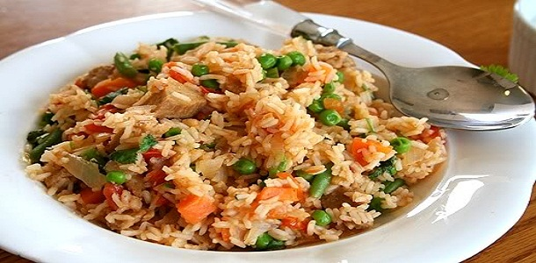

**Jollof Rice**

* 4 cups (or about 1 liter) white rice
* *2 tomatoes and 1 bell pepper (without seeds if you don’t like things too hot)*
* OR 8 ounces (or about ¼ liter) canned tomato sauce and 3 ounces (or about 90 milliliters) canned tomato paste
* Onion
* Salt
* Dry Red Pepper (like Cayenne pepper)
* Meat broth (about 1 cup or ¼ liters) or Magi cubes (about 4)
* Water

Method:

* Unless the rice is pretty clean, you will want to rinse it before cooking it.
* Put the rice and about 6 cups (or about 1½ liters) of water into a pot and place on high heat. (Some people prefer to boil the water and add the rice to boiling water. This is fine too.)
* If you are using fresh ingredients (the tomatoes and pepper) blend them until they are smooth in texture (you can also grind the onion with this mixture).
* Let the rice cook 10-15 minutes.
* Add either the tomato/pepper mixture or the tomato sauce and tomato paste. If you have not added the onion, you can slice or dice it now and add to the pot, depending on how large you like your onions.
* Add enough water to allow the rice to complete cooking (since you will not be draining the rice, it is better to add too little and check up on it often, than to add too much).
* If you have any meat broth from boiling any meat, you can add it to this as well. Otherwise, unless you are a vegetarian, suggest adding about 4 magi cubes for taste.
* Add about 2 teaspoons of salt, and about ½ a teaspoon of dry red pepper (as the rice is cooking, or as you are eating the finished product, you can add more of either one of these so I really suggest starting out small, also useful if different people who will be dining have different tastes).
* Allow the rice to continue cooking until the rice is soft. If it is not dry at this point, then switch the heat to low to allow it to dry the excess water without making the rice much softer. (Also, some people prefer to bake it once they’ve added the ingredients…I suggest 350 degrees or so.)
* Once cooked, add more salt or pepper to it if you wish.